Short biography:

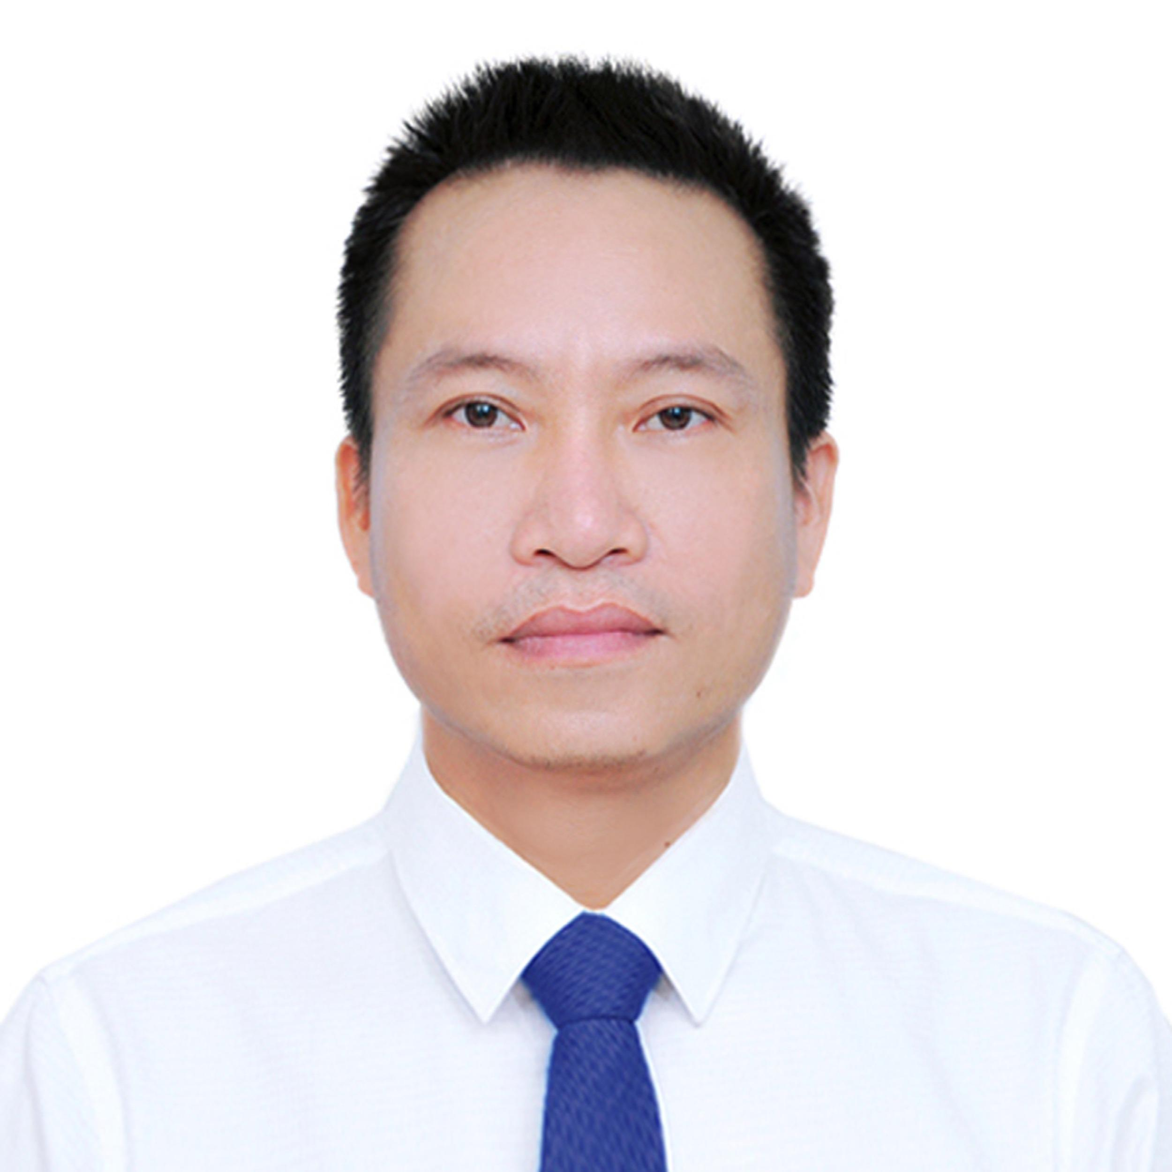
Prof. Hung Nguyen Xuan (H. Nguyen-Xuan) is the Director of CIRTech Institute, HUTECH University, Vietnam. He is currently an adjunct professor at China Medical University (Taiwan) (from 2015 to present) and a visiting professor at Sejong University (South Korea) (from 2014 to present). He is the President of Vietnam Association for Computational Mechanics. He serves as Editorial Board of Composite Structures, Computers & Structures, Engineering Fracture Mechanics and CMC: Computers, Materials & Continua, and Editor of CMES: Computer Modeling in Engineering & Sciences, and subject editor of Underground Space.
Dr. Nguyen-Xuan received his Ph.D. in Computational Mechanics from The University of Liège (Belgium) in 2008. His researches focus on advanced computational methods in engineering, data-driven machine learning modelling and 3D printing. He has published more than 250 peer-reviewed papers indexed in WoS. These papers remarkable made him well-known as a 1% Highly Cited Researcher – Clarivate through eight continuous years from 2014 to 2021 in the category of Computer Science and 2022 in the field of Cross-Field.
Dr. Nguyen-Xuan earned several prestigious awards: Alexander von Humboldt Foundation Digital Cooperation Fellowship (2021), Outstanding Humboldtian (2019), Georg Forster Research – Alexander von Humboldt (2015), Vietnam National University HCMC (2008 – 2013), and Nguyen Van Dao (2011).

